**Day 1-Handson:**

--Creation of ResourceGroup

**Day 2-Handson:**

--Creation of Logic Apps

**Day3-Handson:**

--Creation of devops starter

--While making changes in application then gives the output as shown below

**Day 7-Handson:**

Creation of Azure Kubernetes service

-- Checking node size and node count

Container registry

--After successfully created the develops starter project then build it.

After release Completion Click on the Application Endpoint Link ,shows the below picture that means project successfully running.

--After Successful Build and Release Click on CD pipeline then Right Click on the Second Option and Click on Disable Selected Task.

--Save it , now go back to the CI pipeline and edit it.

-- then click on the ‘+’ symbol and add docker into it.

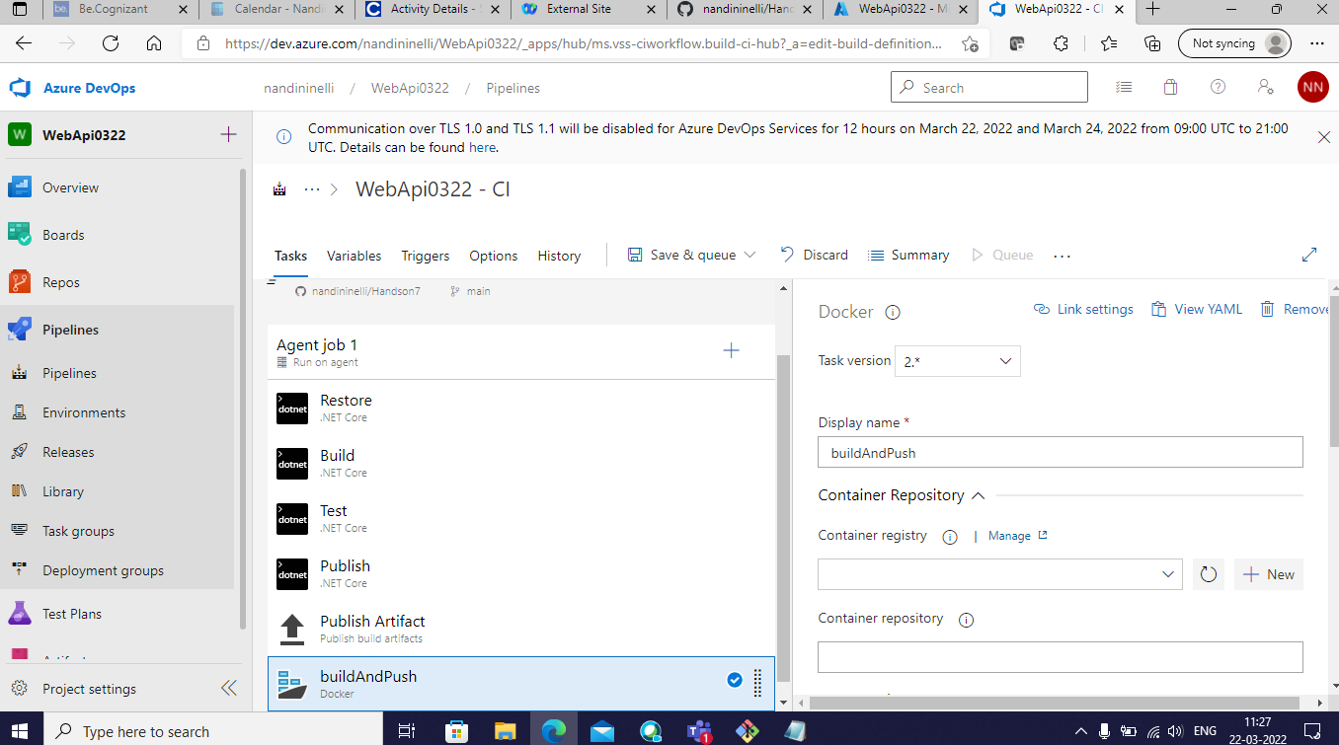

After making the changes then build the project

--Agent job is successful.

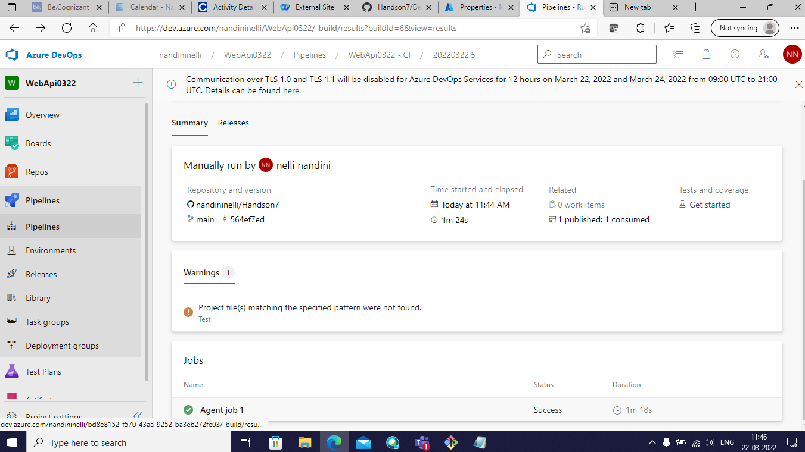

--checking the repositories in container registry.

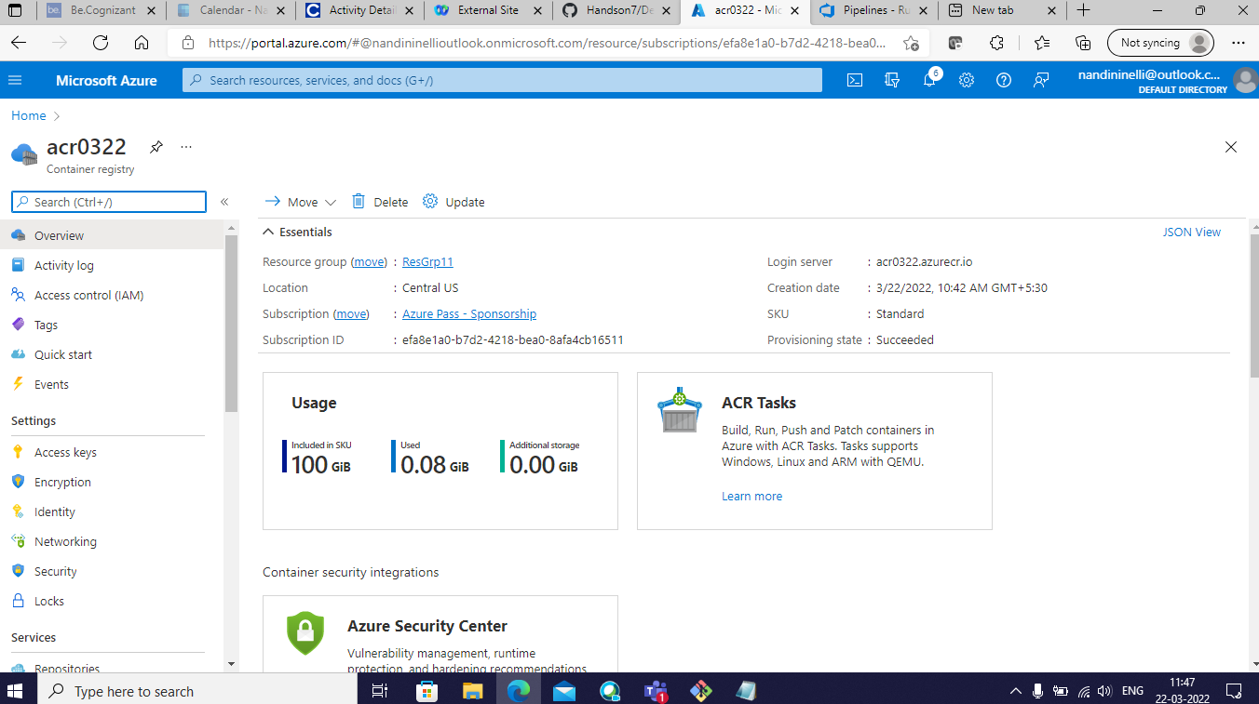

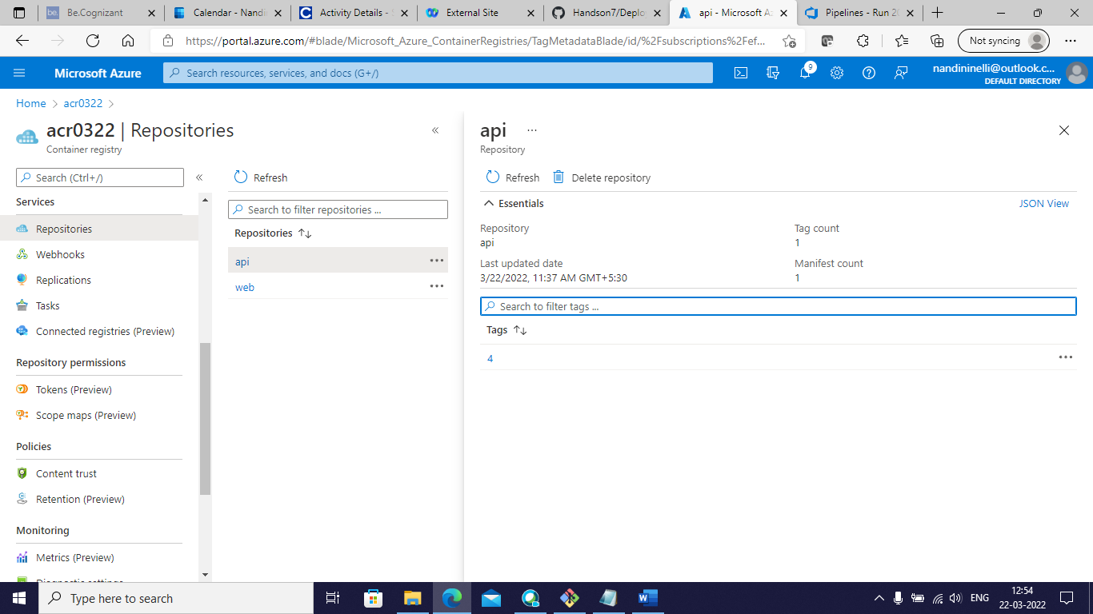

--running the instance

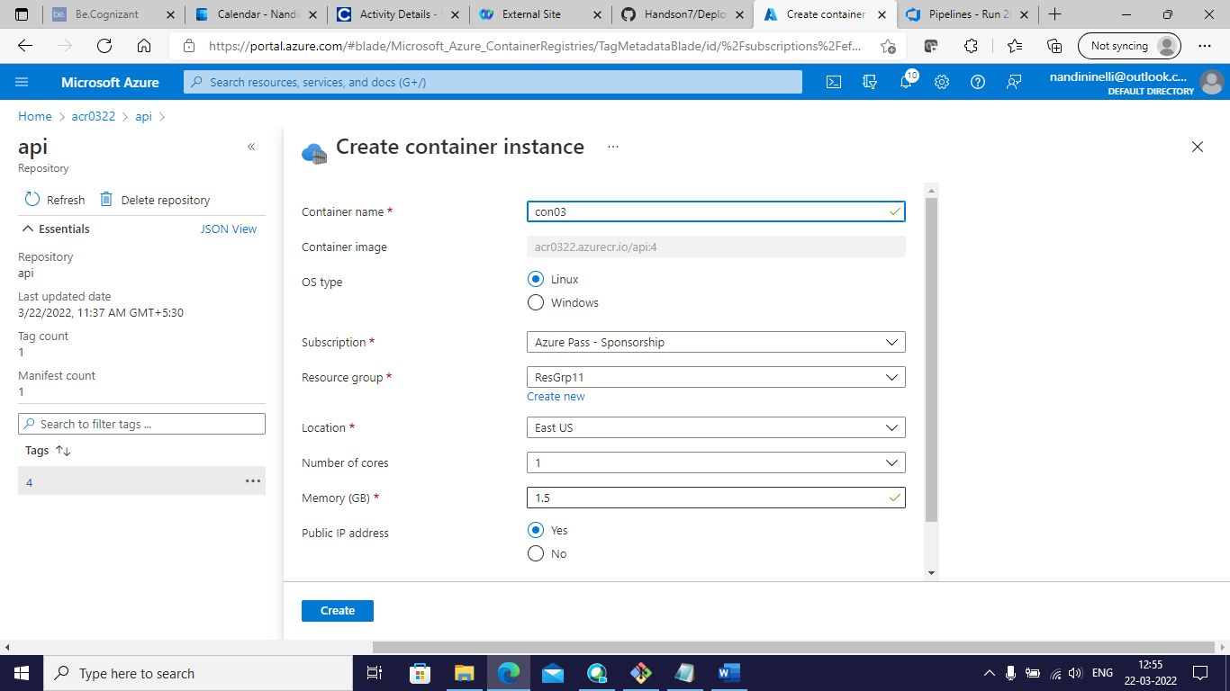

--then go to the resources

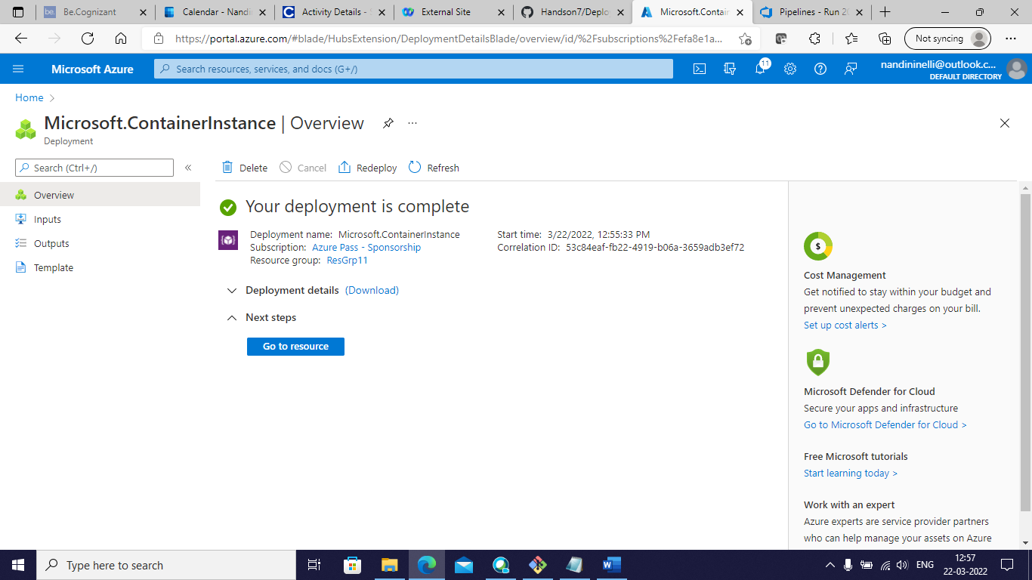

--run the id address

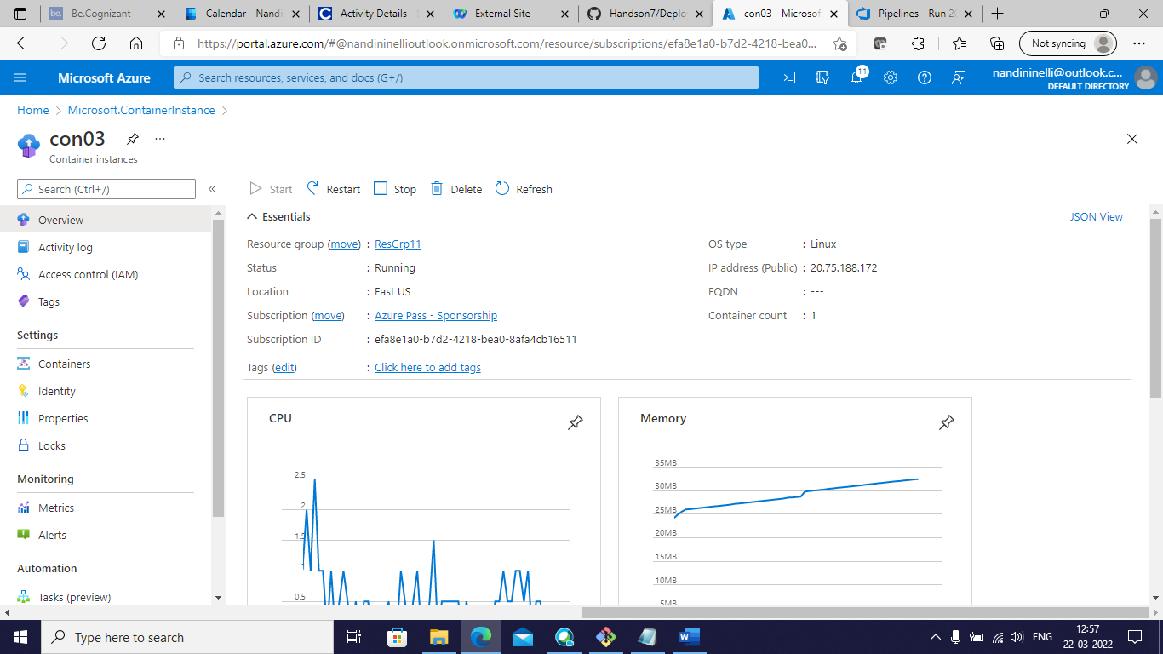

--Output:

